CST 229 – Final Name: __Steven Reeves__________
Wilsonville, Fall 2017

This is a take home final. You must turn in your final on Blackboard by mid-night on Saturday, 9 December 2017. You may use any and all resources available to you to complete this final. Turn in your own work. Do not copy/paste from a source (for example from the internet), instead read the source, understand the material and then put your answer into your own words.

For all problems use the alphabet Σ = { a , b } or { a , b , c } as noted.

- (10 points) For the regular expression ab(a)*…

  - Construct and draw an NFA that accepts strings defined by the regular expression.

Note: Un-labeled arrows are λ

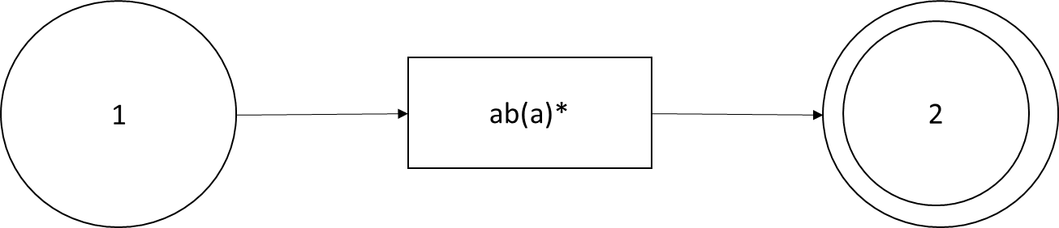

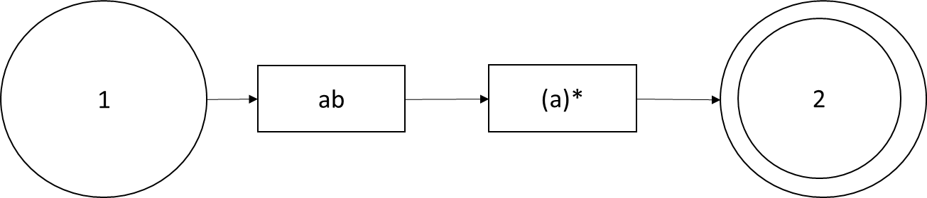
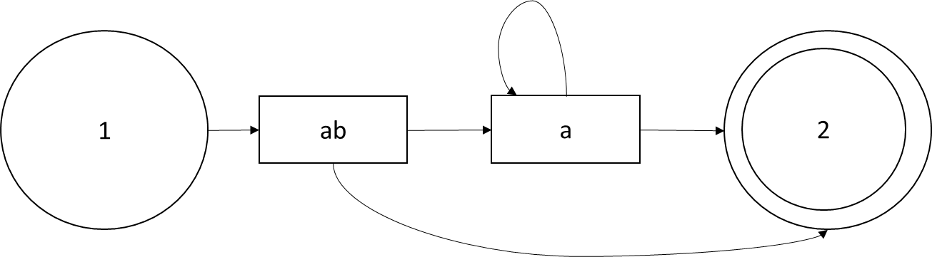
NFA: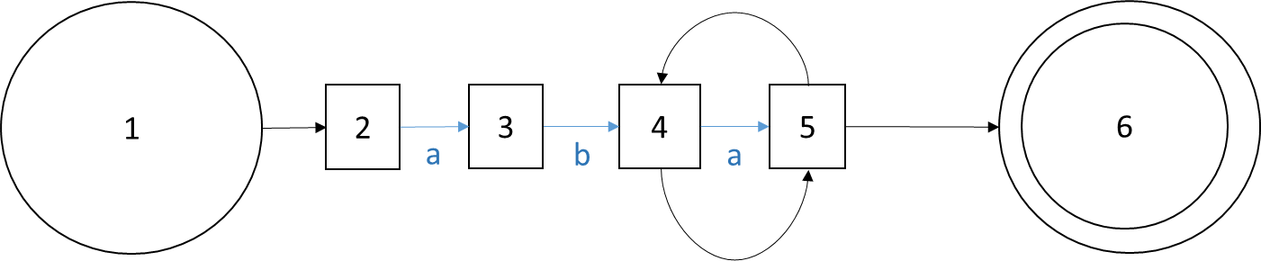

  - Construct and draw the equivalent DFA.
DFA State | a | b | Accept
A{1,2} | B{3} | {}
B{3} | {} | C{4,5,6}
C{4,5,6} | C{4,5,6} | {} | Yes

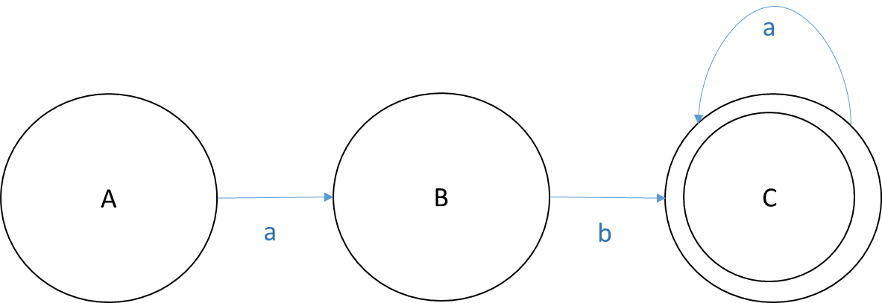
- (10 points) For the language consisting of all strings containing ‘ab’, the following regular expression was provided. Identify and describe all errors, if any.

(ab)*(a | b)*

The Kleene closure for the first part should be a +. With both the sections Kleene’d, they can both be nothing giving you a string of “”. If the first part had a positive closure, we could ensure the string contains “ab”. Additionally, having (a|b)* at the end doesn’t give us the ability to make a string such as “bbbbbbabaaa”. It only allows us to have the “ab” at the beginning. We also wouldn’t be able to construct any string with alternating a’s and b’s after the (ab)*. A more appropriate RE would look something like this:

Σ *(ab)+ Σ*

(Anything from the language as much as you want, or not) (“ab” at least once) (Anything from the language as much as you want, or not)

- (10 points) For the language consisting of all strings where the number of a’s is equal to the number of b’s, the following grammar was created. Identify and describe all errors, if any.

S → aSb | bSa | λ

“aababb”
S
aSb
aSbb
aaSbbb
aabSabbb
aababbb ← Extra b at the end

This grammar only allows addition of a letter with its counterpart on the other side. “aaabbb” would work great. “aababb” does not. If we add an extra S to the end of the first two options. This grammar will work. This essentially gives the ability to move the insertion of the next aSb or bSa over to the right.

S → aSbS | bSaS | λ
“aababb”
S
aSbS
aSb
aaSbSb
aabSb
aabaSbSb
aababSb
aababb

- (10 points) A string can be viewed as alternating sequences of a’s and b’s. For example, a string that starts with an ‘a’ will have some number of a’s, followed by some number of b’s, followed by some number of a’s, etc. For the language that consists of all strings where there is an odd number of occurrences of sequences of a’s….
  - Valid strings: aa, aababaa, bbaaa, abbaababbbaaaba, aaab
  - Invalid strings: b, aba, baaba, abaaaabbaabbbba

  - Create a regular expression for this language.

(b*a+ b*) (b+ a+ b+ a+)*

(one sequence of a’s) + (even number of sequences of a’s, or 0)

  - Create a finite automata that accepts this language.
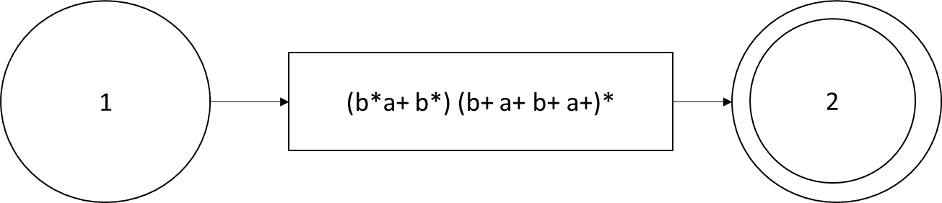

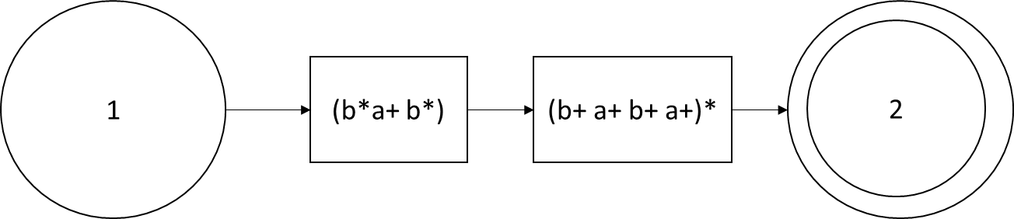
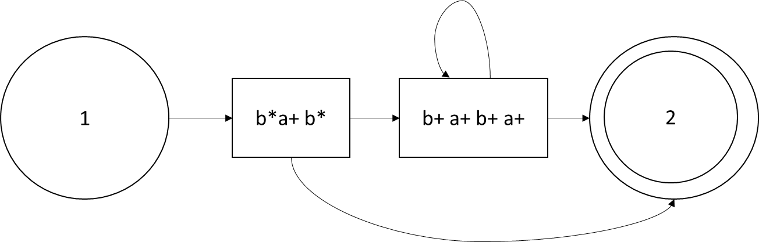
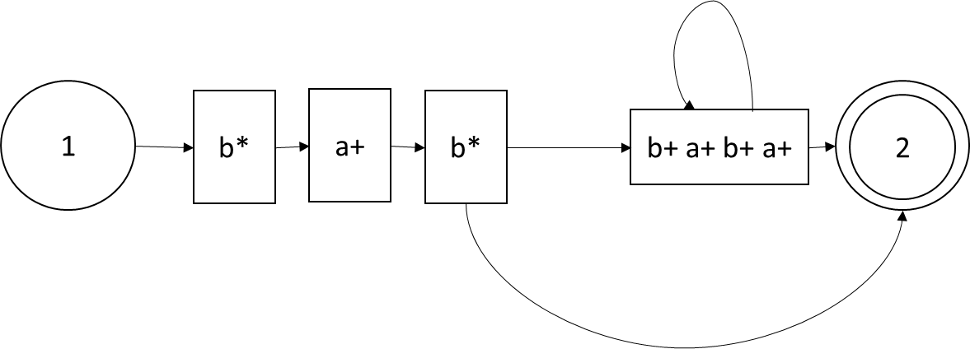
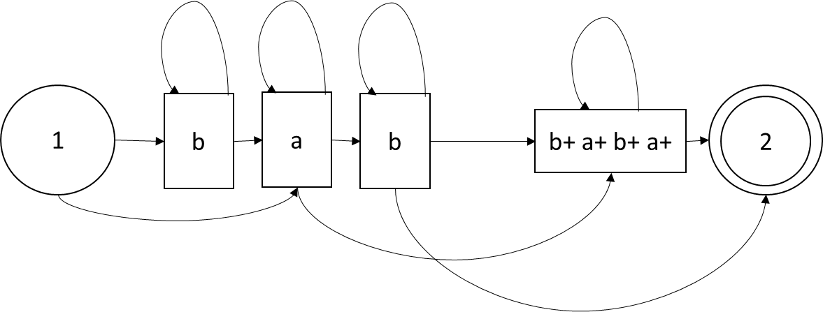
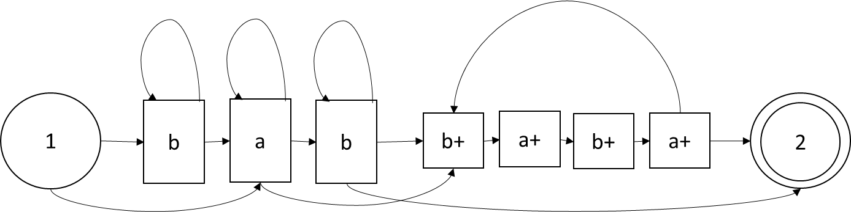

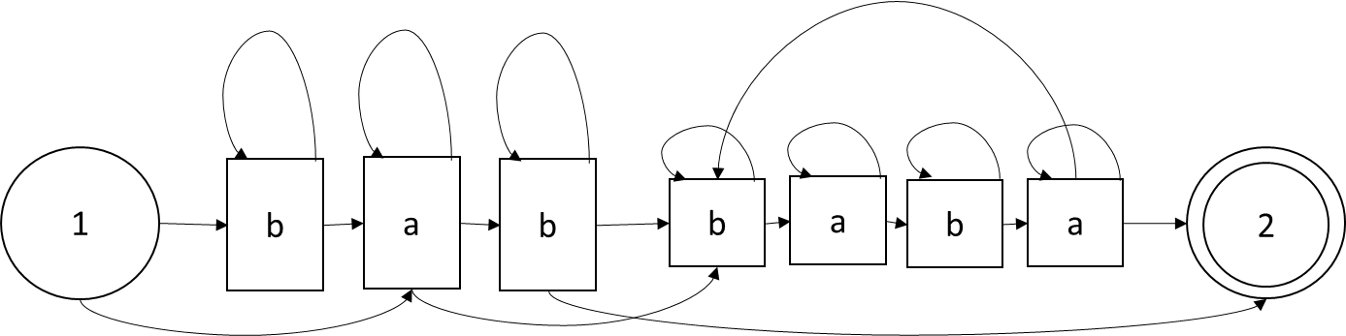
NFA:
<Asked>
5) (15 points) For the language a^{n}b^{n+m}c^{m}, where m, n ≥ 0...

  - Create a context-free grammar that generates this language

S→ T
T → aTbT | cTbT | bTcT | bTaT | λ

  - Create a pushdown automata that accepts this language.

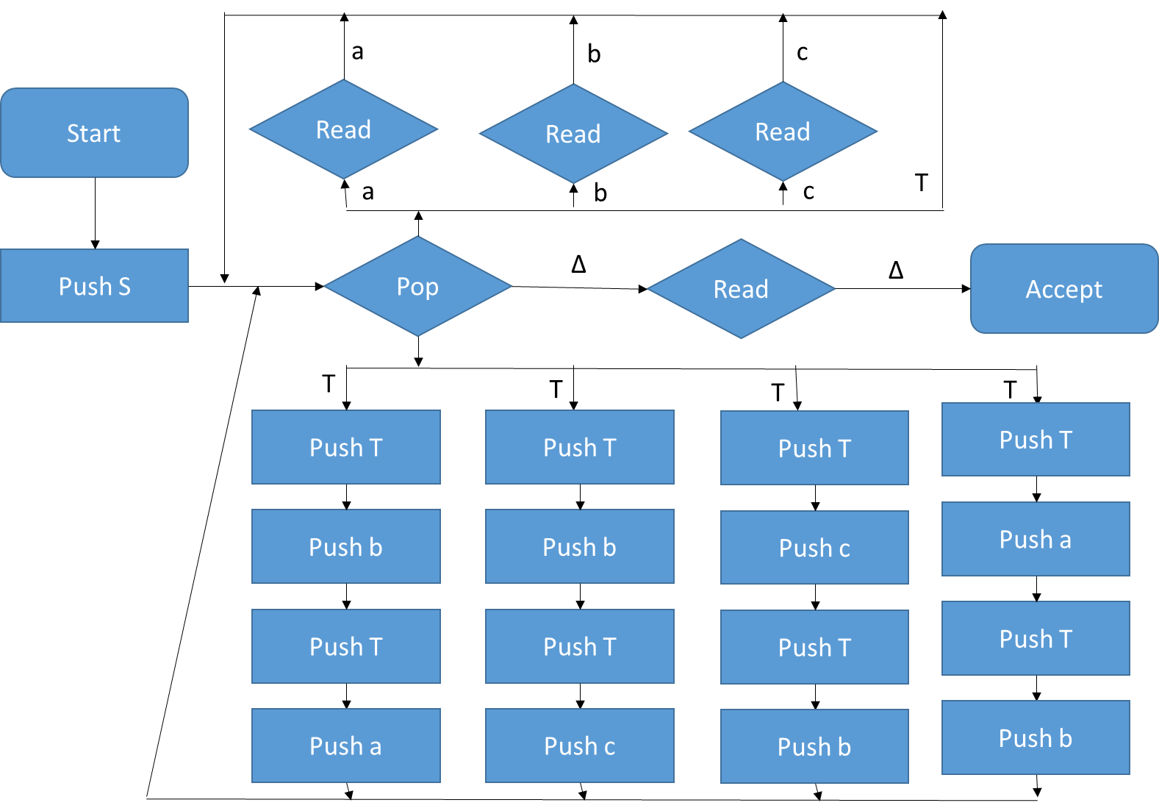

6)(15 points) For the language defined by {a^{n}b^{m}: m ≤ 2n, m, n ≥ 0}…

  - Create a context-free grammar that generates this language.

S→ T
T → aTbTb | bTbTa | bTaTb | aTbT | bTaT | λ

  - Create a pushdown automata that accepts this language.

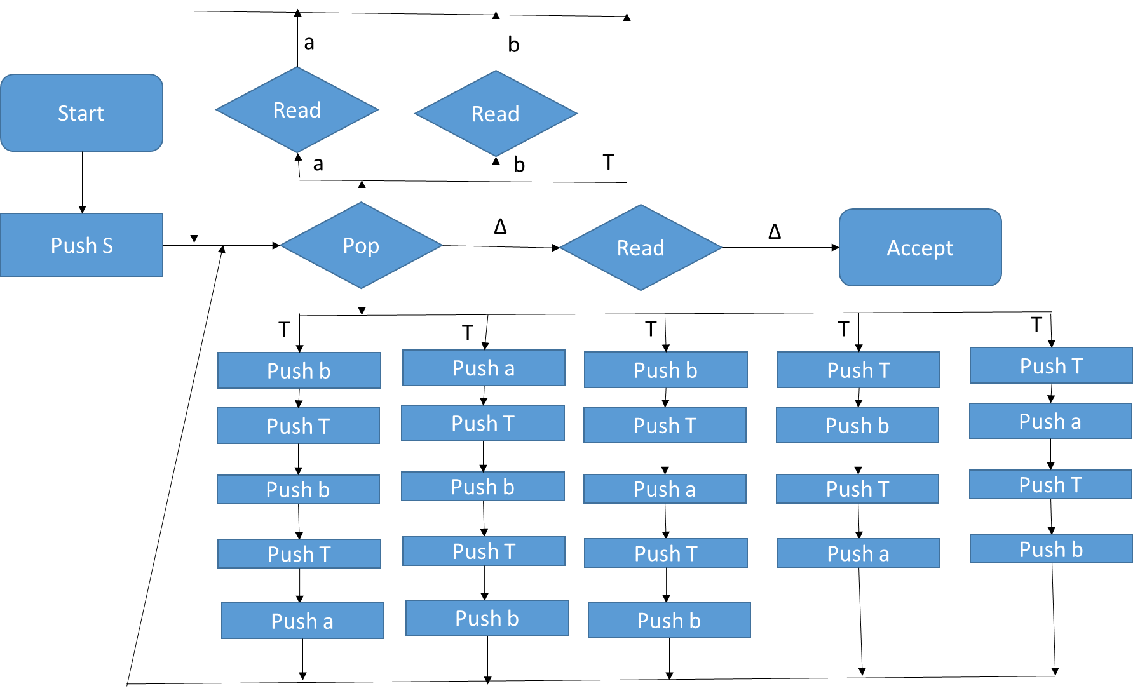
7)(15 points) Construct a Turing machine that accepts (halts on) all strings of odd length with ‘a’ as the middle letter. You may define and use Turing machine subroutines in your solution.

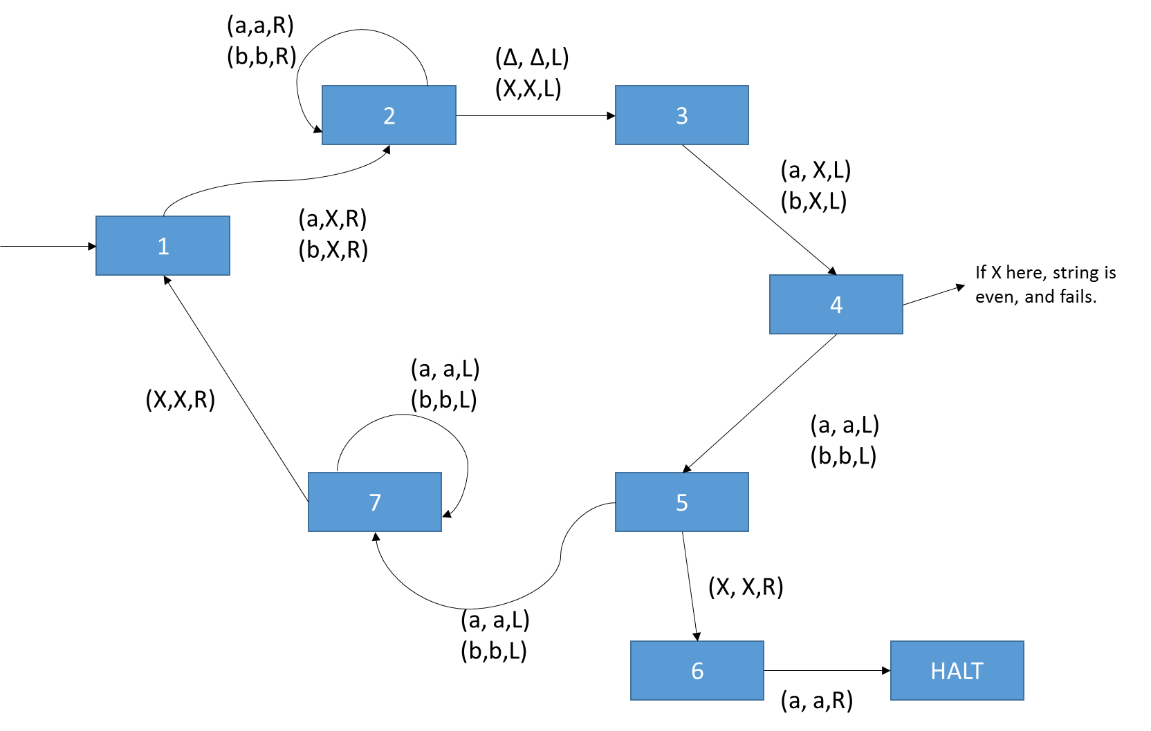

8)(15 points) Construct a Turing machine that removes all b’s from a string. The resulting string must not contain any blank spaces. You may define and use Turing machine subroutines in your solution.
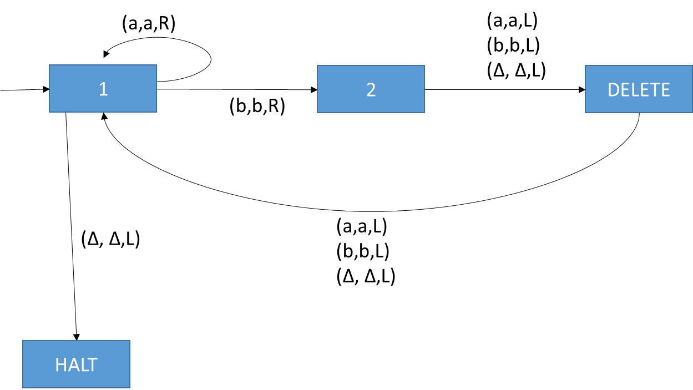

Note: Delete ends up pushing tape head 2 index to the right of deleted character, which is why the left move is needed above.

